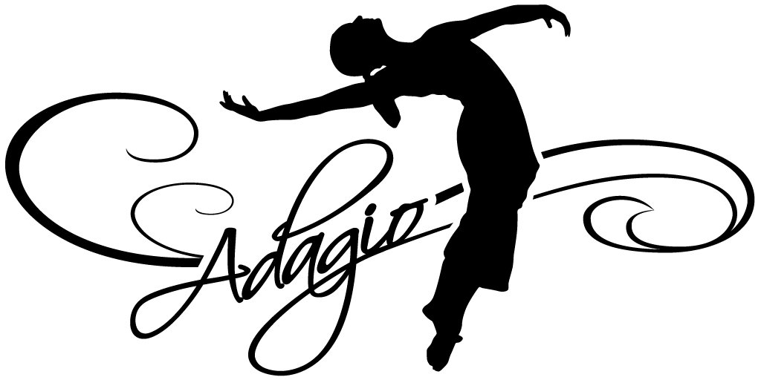 Welcome to the studio that has it all! We conduct daily dance classes in the areas of Ballet, Pointe, Modern, Jazz, Hip Hop, Tap, Tumbling, Musical Theater, Creative Movement, Adult Cardio Pop and Adult Barre Blast. Whether you are a beginner, intermediate, or advanced dancer, we are confident our staff will meet your needs. We believe in the consistent progression of student’s technique and self-esteem through excellent instruction and the student’s drive and commitment to dance. The main focus at Adagio School of Performing Arts is on the individual’s growth both as a dancer and as a person. Adagio staff members have earned college level degree and training in dance performance and teaching in order to provide its students with top notch, educated based instruction. Adagio’s curriculum for each genre of dance offers each student to progress through a leveled program with confidence and the physical ability to excel safely. We aim to encourage all of our students to work hard, to strive for improvement, have self-discipline and be respectful of others and for the art of dance. Our students may either dance as a form of recreation while developing grace and poise, or strive to achieve a high level of technique and performing skills which could lead to a professional career. Adagio has invested high quality dance facility in order to give its dancers a professional and safe environment in which to perfect their skills. All three studio rooms have Marley covered sprung floors and air conditioning. At any time you can find our waiting room full of friendly families, enjoying their dancers in the viewing windows. Adagio prides itself on a having a very professional atmosphere while still maintaining close relationships with each student and their families.

Performances!
Our goal is to have an event in which the dancers can experience the fun and excitement of performing. It will be a celebration of their progress, hard work, and talent. We aim for low stress and high energy! Students have the option to perform in Adagio’s annual Summer Dance Festival and/or travel with our award winning competition team. Competition dances are learned in “choreography class,” held separate from the students training classes. As part of our mission at Adagio, we believe the process of building a good performance is having efficient rehearsals, on-going dance training, a supportive community, and educated staff.

Procedures
- Please notify the teacher if there are special arrangements or only certain people are to pick up your child. We ask that students arrive early and on time so class can begin appropriately, a ride should be available at the end of class.
- Sick Policy: If your child has had a fever, vomited or contagious illness within the last 24-hours, please keep them home and inform the office of their absence. (815) 434-3920
- Dress Code: All dancers must wear leotard and tights to ensure the lines of the body are seen by the instructor. No street clothes. Students in Level 1 and above must wear a black leotard and tights. Booty shorts and half tops are allowed as long as they are tight to the body for tumbling and hip hop. Names should be in all shoes. The appropriate shoes must be worn in each class (ballet, tap, jazz shoes). Adagio’s Dance Store has all the required shoes, tights, leotards, bags and Adagio apparel.
- Hair should be pulled back tight in a bun and no loose jewelry.
- Phone Policy: Student phones are to remain in their bags on silent. If staff sees a phone out, a parent will have to claim it from the office.
- Always be on time for class – this means arriving early, being dressed with shoes on and stretching so when your instructor starts class everyone can begin. Direct your attention to your teacher as a sign of respect throughout class and at the end, you may clap, curtsey or bow as a way of thanking fellow students and teachers for class.
- Do not chew gum. Please keep water bottles off the dance floor, you may get a drink during breaks. Water and dry snacks should be the only food items brought into the studio.
- Please be respectful of the studio by cleaning up after yourself, throwing away garbage, walking in hallways, turning off lights and closing doors behind you. Be respectful of S & S Travel, located in the front of the studio by walking and keeping noise limited during business hours.
- Our schedule often follows the schools for closings, though we are open on some holidays such as Columbus Day, etc. Please watch for newsletters coming home. Closings for holidays and inclement weather will be announced on Remind and Facebook first, then through our voicemail and sign on the door as we can. Sign up for Remind by texting #81010, enter “adagios” in the text box or email adagios@mail.remind.com and leave the subject area blank.

Adagio has ongoing, open registration all year. Stop in, email or call for more information.

