Adagio School of Performing Arts
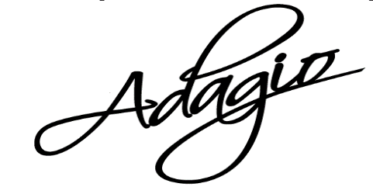Upcoming Events
Monday, February 19
President’s Day
Classes ARE in session

Sunday, February 25
Competition Preview Show @ OHS Auditorium 3:00pm

March 2018
Registration for Summer &
Fall classes will begin

March 2018
SDF T-Shirt Orders Begin

March 25 – March 31
Spring Break/No classes

April 2
Classes Resume

Tuesday, April 10, 2018
SDF Ticket Sales Begin: 6:30-8p

May 2018
Summer Class Registration Due

Fri., May 4 4-9p &
Sat., May 5 8a-3p
Technical Rehearsal @ OHS

Sunday, May 6
Dress Rehearsal @ OHS 12pm
All Students in Attendance

Fri., May 11 @ 6pm
Sat., May 12 @ 6pm
Sun., May 13 @ 1pm
Summer Dance Festival
@ OHS Auditorium

June – August 2018
Camps & Classes for ALL Ages

August 2018
Open House & Shoe Fittings
EVERYONE needs to be signed up for REMIND
***Please sign up for Remind by texting to the number 81010, enter @adagios in the text box

302 W. Main St., Ottawa, IL 61350 T: 815.434.3920
www.ottawaadagio.com Email: info@ottawaadagio.com
Congratulations to September’s Students of the Month - Jenna Smithmeyer, Karsyn Moore, & Megan Kane

Competition Preview Show @ OHS Sunday, Feb. 25 @ 3pm – Here is a chance to see all of our dances we have going to competition this year! Our competition team & teachers have put in a lot of hard work & time! Come support our team before they dance before the judges! Doors open at 2:45, $5 at the door.
Registration Forms for Summer & Fall will be given out in the next few weeks. Current students will have first chance at fall classes before we open it up to new students. Classes fill up quickly & will close once full. Included will be level recommendations by the teachers – the recommendations are for fall, you should sign up for summer classes at the same level you are in now. Please trust that the teachers have your child’s best interest in mind when doing their placement, dancers move individually, not as a class.
Adult Classes
Barre Blast: Mondays @ 6:30p, Wednesdays @ 6:30p (Beginner class), and Thursdays @ 9:00a
POUND: Tuesdays & Thursdays @ 6:30p

Summer Classes – We will be offering 8-week classes for Creative Movement, PreK, Kinder, & all levels. Information coming soon! These classes are great for little ones just starting out & current students wanting to stay active & work towards that next level.

Private Lessons will be offered this summer. Private instruction is great for beginning dancers that are eager to get caught up to their age level for fall classes and the advanced dancer to refine and improve their skills. Speak to the office for more information.
SUMMER DANCE FESTIVAL 2018
Preparations for SDF ’18 are in full swing! Choreography has begun, costumes are ordered, props built & excitement is growing. We have a fantastic show coming together!
*Hip Hop shoes need ordered now if you need for the show.
*Please remember attendance is crucial to the success of the show. It doesn’t go unnoticed when someone is missing. We understand things come up – please discuss scheduling conflicts with your teacher in advance & notify the office of all absences.

Reminders
- If your child has had a fever, vomited or contagious illness within the past 24-hours, please keep them home & inform the office of their absence. Call 815/434-3920 or text with REMIND
- Names should be in all shoes and ALL ballet shoes need straps sewn!
- Hair should be pulled back tight in a bun for ALL classes and no loose jewelry. Proper attire in ALL classes.
- Check lost & found often – a lot of items are being left behind after class. Items are discarded on a regular basis.

