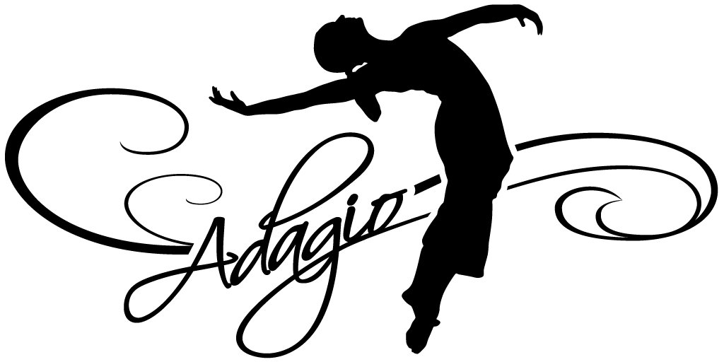 Welcome to the studio that has it all! We conduct daily dance classes in the areas of Ballet, Pointe, Modern, Jazz, Hip Hop, Tap, Tumbling, Musical Theater, Creative Movement, Adult Cardio Pop and Adult Barre Blast. Whether you are a beginner, intermediate, or advanced dancer, we are confident our staff will meet your needs. We believe in the consistent progression of student’s technique and self-esteem through excellent instruction and the student’s drive and commitment to dance. The main focus at Adagio School of Performing Arts is on the individual’s growth both as a dancer and as a person. Adagio staff members have earned college level degree and training in dance performance and teaching in order to provide its students with top notch, educated based instruction. Adagio’s curriculum for each genre of dance offers each student to progress through a leveled program with confidence and the physical ability to excel safely. We aim to encourage all of our students to work hard, to strive for improvement, have self-discipline and be respectful of others and for the art of dance. Our students may either dance as a form of recreation while developing grace and poise, or strive to achieve a high level of technique and performing skills which could lead to a professional career. Adagio has invested high quality dance facility in order to give its dancers a professional and safe environment in which to perfect their skills. All three studio rooms have Marley covered sprung floors and air conditioning. At any time you can find our waiting room full of friendly families, enjoying their dancers in the viewing windows. Adagio prides itself on a having a very professional atmosphere while still maintaining close relationships with each student and their families.

Performances!
Our goal is to have an event in which the dancers can experience the fun and excitement of performing. It will be a celebration of their progress, hard work, and talent. We aim for low stress and high energy! Students have the option to perform in Adagio’s annual Summer Dance Festival, Winter Dance Festival (performed every other year) and/or travel with our award winning competition team. Competition dances are learned in “choreography class,” held separate from the students training classes. As part of our mission at Adagio, we believe the process of building a good performance is having efficient rehearsals, on-going dance training, a supportive community, and educated staff.

Procedures & Policies
- Please notify the teacher if there are special arrangements or only certain people are to pick up your child. We ask that students arrive early & on time so class can begin appropriately, a ride should be available at the end of class.
- Sick Policy: If your child has had a fever, vomited or contagious illness within the last 24-hours, please keep them home & inform the office of their absence. (815) 434-3920
- Dress Code: Having a dress code ensures the students understand they are in a structured class and clothing is not a distraction. A uniform appearance enables the teachers to see the dancer’s movement, placement and lines so proper corrections can be given for the benefit of the dancer’s education. ALL DANCERS must adhere to the dress code or they will sit out of their class(es) for the day. On the third no dress day, your account will be charged for the appropriate items needed. Adagio’s Dance Store has all the required shoes, tights, leotards, bags & Adagio apparel.
- Introduction to Dance I & II – Pink Leotard (a skirt or tutu with it is okay) & tights for ALL students.
- Level I through Level V – Black leotard and tights (pink or tan) for EVERYONE in Ballet, Jazz, Tap, Modern, Stretch & Conditioning, Pointe Prep, & Tumbling. NO exceptions. Dance sweaters & leg warmers are optional. Hip Hop students may wear a t-shirt & pants. NO street clothes will be allowed in any class.
- Names should be in all shoes. The appropriate shoes must be worn in each class (ballet, tap, jazz shoes).
- Hair must be pulled back in a bun, braid or clean ponytail, no hair should be in the dancers face. If hair is too short, it should be pinned back off the face.
- No jewelry – earrings, bracelets, necklaces, rings, fit bits, or watches on the body during class.
- Phone Policy: Student phones are to remain in their bags on silent. If staff sees a phone out, a parent will have to claim it from the office.
- Always be on time for class – this means arriving early, being dressed with shoes on & stretching so when your instructor starts class everyone can begin. Direct your attention to your teacher as a sign of respect throughout class & at the end, you may clap, curtsey or bow as a way of thanking fellow students & teachers for class.
- No food or drinks in any class. Do not chew gum. Water should be brought in a water bottle and left with your bag. Water breaks will be given during class. Water & dry snacks should be the only food items brought into the studio.
- Please be respectful of the studio by cleaning up after yourself, throwing away garbage, walking in hallways, turning off lights & closing doors behind you. Be respectful of S & S Travel, located in the front of studio by walking & keeping noise limited during business hours.
- *Our schedule often follows the schools for closings, though we are open on some holidays (ex. Columbus Day, etc). Closings for holidays/inclement weather will be announced on Remind & Facebook first, then through our voicemail & sign on the door as we can. Sign up for Remind: text #81010, enter “@adagios” in the text box or email adagios@mail.remind.com & leave the subject area blank.

